**Accepting a pull request**

Step1: A pull request has been generated by a user

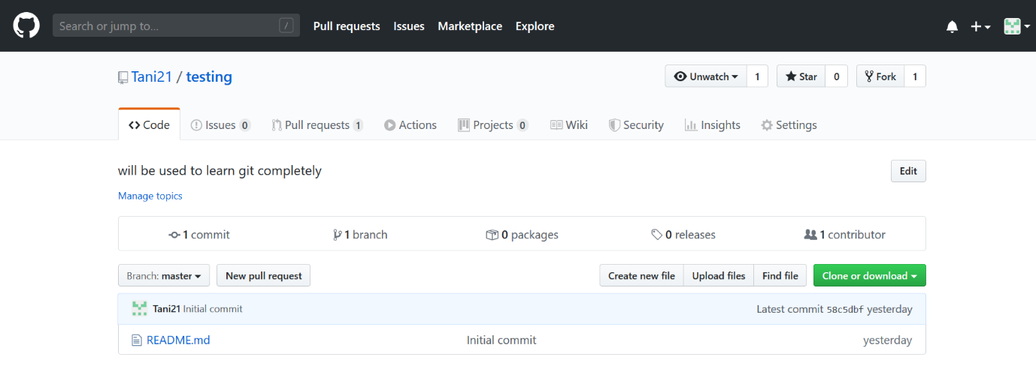

Step2: Check for the changes made by the other user.

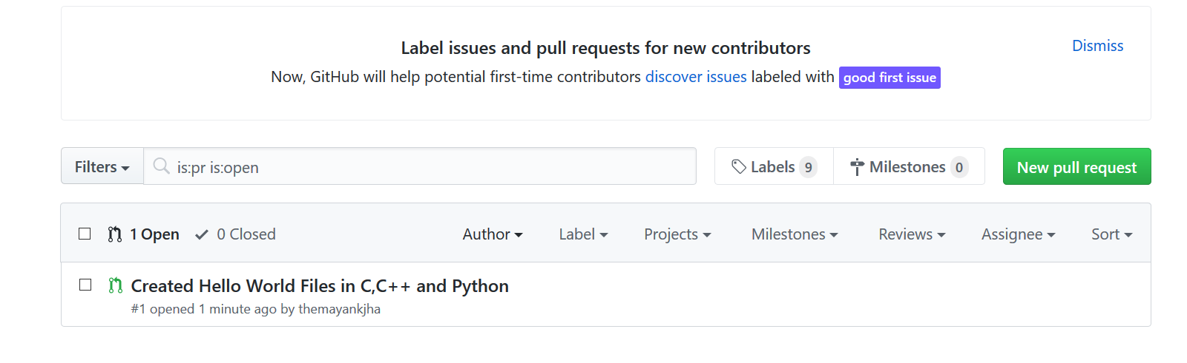

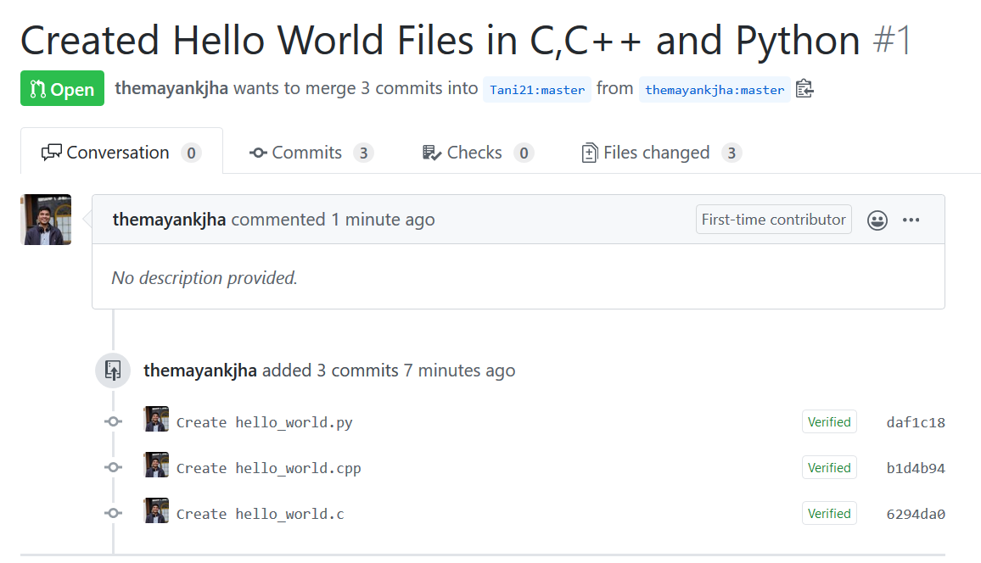

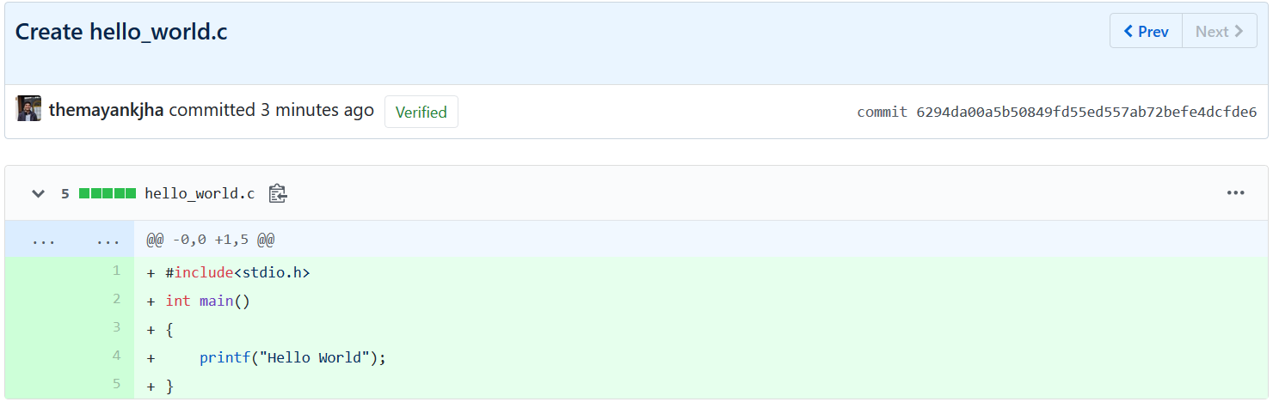

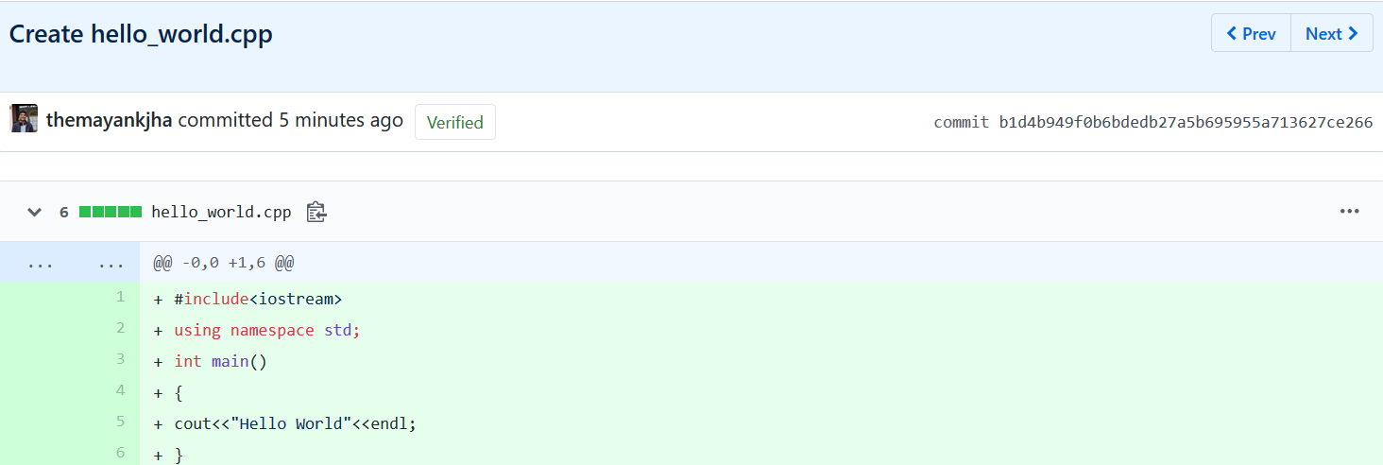

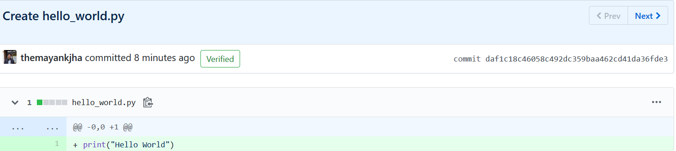

Step 3: The pull request can either be merged, or closed, after checking for the contents of the pull request.

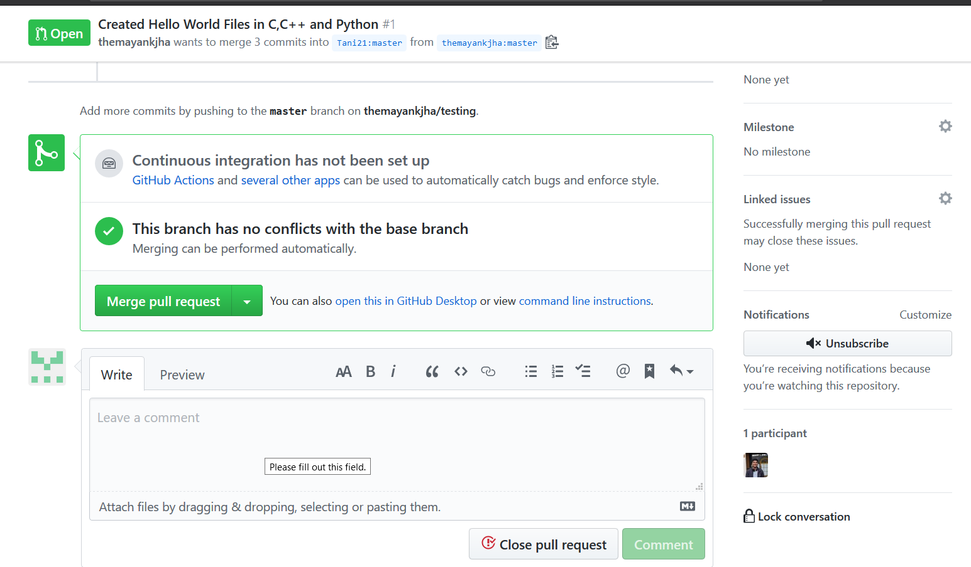

Step4: Confirm merging the pull request

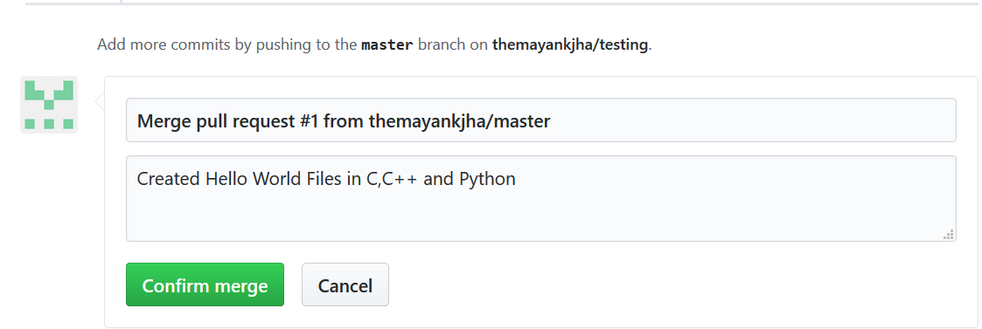

Step 5: The pull request is accepted and successfully merged.

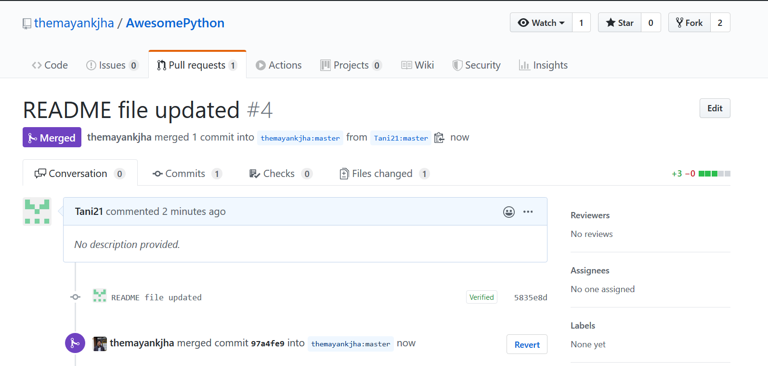

**Creating a pull request**

Step1: You can either clone the repository, and edit the contents of the file using git bash, or fork the repository and edit the files on github itself.

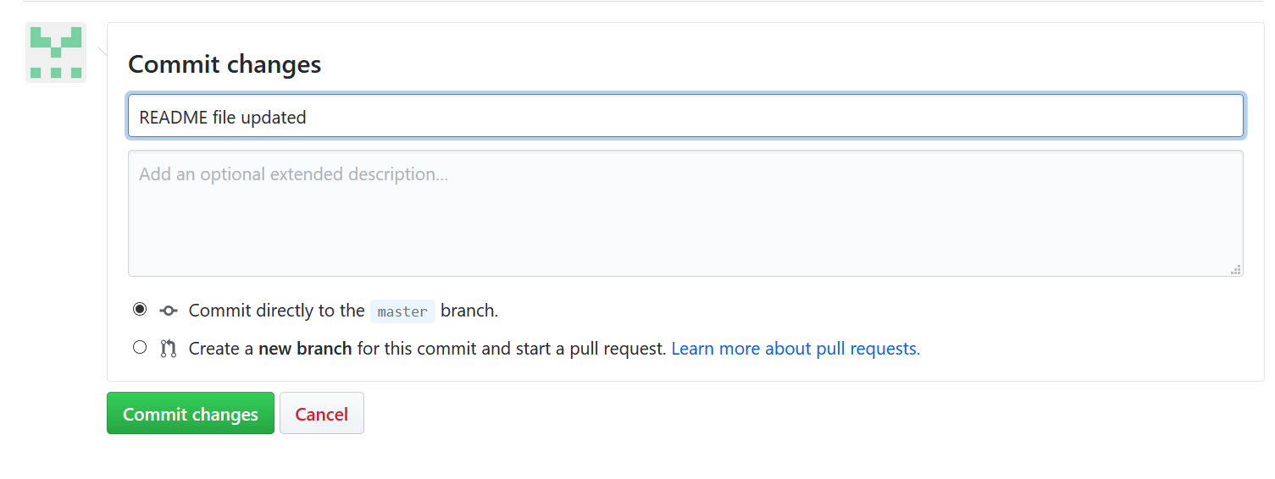

Step2: You can generate a pull request for the same

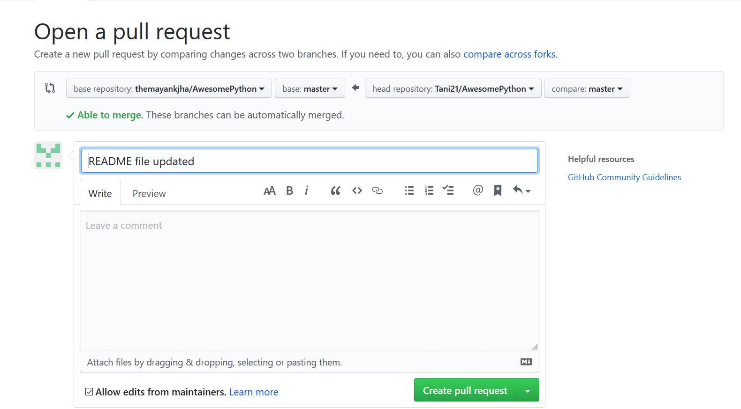

Step3: After creating a pull request, wait for the contributor to accept it or reply to it. In case your pull request gets accepted, the following message will be displayed.

